VBS Music & Drama Camp
(For children who have just finished 1st-6th grade)
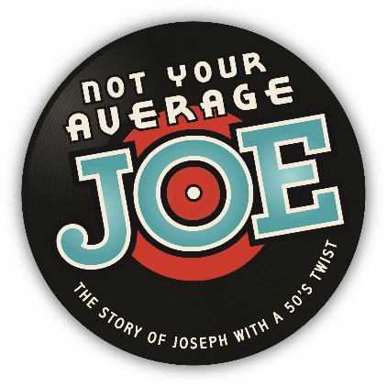

JUNE 20-24, 2014 – 9 a.m. – 3 p.m.
PERFORMANCES ON JUNE 25 & 26, 2016

THE PRESBYTERIAN CHURCH
23 South Front Street, Hamilton, OH
Ms. Rosie Jennings, Church Education Leader
513-867-5411

REGISTRATION FORM – (DEADLINE IS June 10, 2016!)
Auditions for Speaking parts 6/2 & 6/7 (5-8 p.m.)

CHILD’S NAME:________________________________________________ ______________

Grade just finished: ______ T-Shirt Size (circle) YM YL AS AM AL

PARENT/GUARDIAN NAMES:__________________________________________________

__________________________________________________

ADDRESS:_________________________________________________________________________

___________________________________________________________________________________

Phone Numbers:___________________________________________________________________

Email Address:_____________________________________________________________________

Fee: $25.00 (for T-shirt, book, lunches, craft supplies)

Make Checks payable to The Presbyterian Church (fee should accompany registration)

Are you interested in a speaking part? Yes______ No______

